E. Wavelength – distance between ____________________________

- __________________________________

- symbol ____________________

- length of ______________________________________

Wavelength? _______________________________
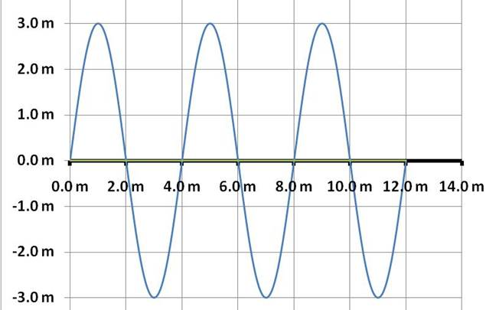

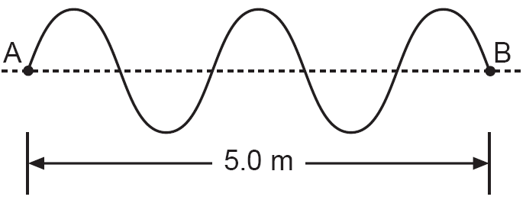

Ex)
Amplitude? Wavelength?
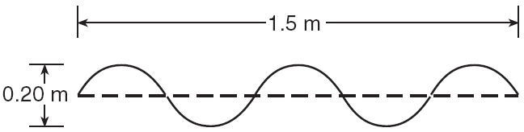

Ex) Amplitude A?, B?, C?
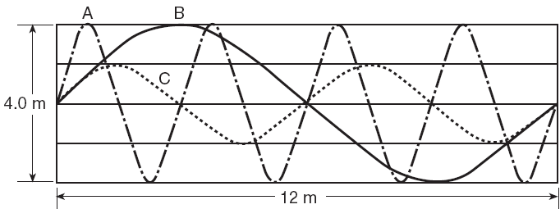
F. Speed – the number of _______________________________________

Ex) f = 40. hertz. V = ?

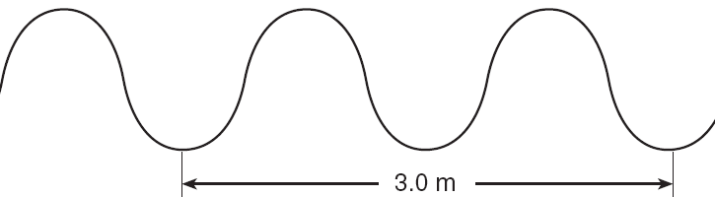

Ex) Period = 5.0 sec. V = 20. m/s Wavelength = ?

3. Velocity sound = ________________________-

(Air, Reference Table, room temperature)

Velocity light in a ______________________

About how many times faster is light than sound?

Gap between time you see lightning and time you hear thunder tells ....

Summary

D. Doppler Effect – _________________________________________ of a wave
when there is relative _______________________________________________

Which way is this ambulance moving?
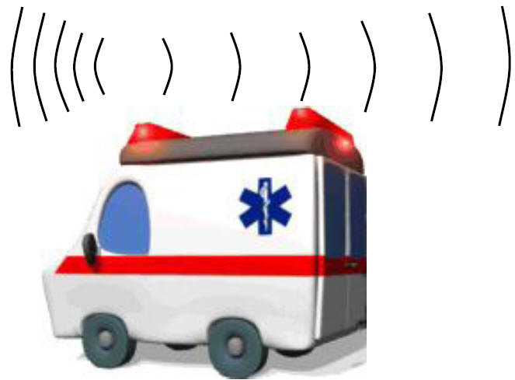

"Which way is the source of this wave moving?"
