Ex 3) Pendulum
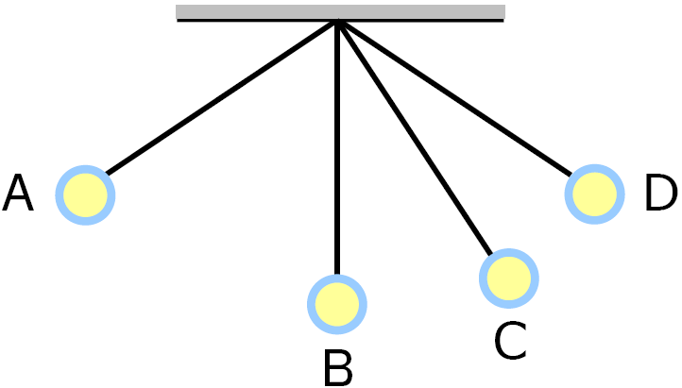

PE Max. at _____________
KE Max. at ___________________
PE at Extremes = ______________________
KE @ Extreme = _______________
PE @ Bottom always = ___________________
Ex 4) 1.0 kg pendulum swings to a height of .20 m above its lowest point.
K.E. of pendulum at lowest point?
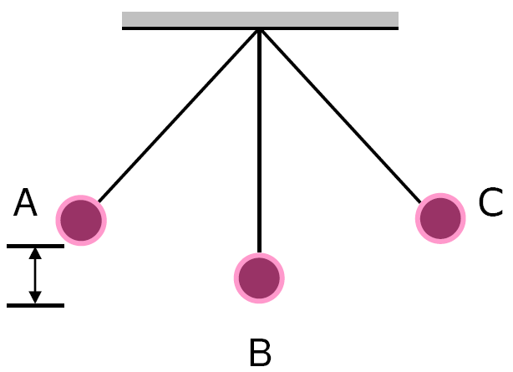

Ex 5) 5.00-kg cart at foot of a hill 10.0 m high. For cart to reach the top of the hill, what is minimum KE of cart in the position shown? [neglect friction.]
